Final Concert
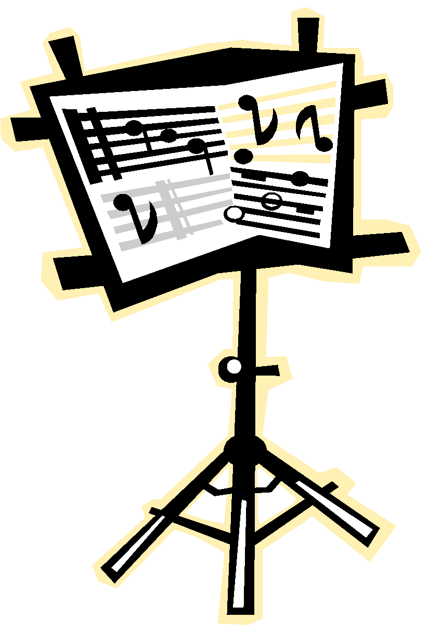
DATE in the Location
Time - Assembly for the school
Time - Concert for families
Arrive @ Time for the evening concert
Concert Uniform: White shirt and black pants/skirt/shoes for BOTH concerts.
Please ask for help if needed.

Reminder: DRESS REHEARSALS ON DATES

In preparation for your concert make sure to practice regularly by using the Big IDEA:
IDENTIFY small spots in your pieces, DECIDE what features you need to work on,
EXECUTE a variety of Strategies and ANALYZE how you did.
Title of Concert Song  Or Task | Check this box when you have mastered the assigned spot and can play it with confidence. | Perform the song for a family member or an adult and get their signature!
Teachers fill this column in ahead of time with Songs (perhaps #86 in the book, or concert music titles) or spots in their music with specific goals (OMGs)

Name:_________________________ Classroom Teacher___________
TURN COMPLETED SHEET IN BY DATE for a Surprise (ie sticker or “karate” belt)

